Impact of Data Analytics and Big Data on Orgainzation Growth

Kaveri Hari Charan Yadav
Department of Computer Science
Southeast Missourin State Univeristy
Cape Girardeau, Missouri, United States of America
hkaveri1s@semo.edu

Abstract—In today’s world data analytics and big data play vital role in computing field, where these two branches are achieving the organization goals by performing on enormous amount of data sets and providing better decision making. The paper describes the way data was there and the way it used in different eras and the proposed model gives better decision making results on the data because of the implementation of user recorded data and previous business data while performing analytics so that the organization will have the precise data and decisions can made accurately for the next products thus organization will be benefited. This paper also describes some of the facts about the big data and data analytics transforming the organization growth.
Keywords—Data, Data Analytics, Big Data, Analysis, Decision making.

Introduction
Data is the building block for everything in the universe. The term data is been heard from ages. Data is available in massive amounts, in general data is categorized in to two terms one is quantitative data and other one is qualitative data. The quantitative data means that can be measured for example how many pens are there in your pencil box, whereas on the other side qualitative data means that cannot be measured for example the color of the flower is yellow. So, in today’s world due to enhancement of technology everywhere new applications are created and each application will develop enormous amount of data every second every day. The traditional way of storing the data ages ago was started by using punch records and further the magnetic tapes came into existence. It was a huge task earlier to store the data but now it has become easy to store because of improvements and effective design in integrated circuits. If you imagine the world without existence of the data, its nothing without data.

The main primary backbone for any organization in the world is data. Every organization need to maintain their data in an effective manner for further usage and for organization growth and extract. In contrast these days storing the data has been done at a low cost, so every organization have multiple ways to store the huge existence of data in the market for example the best and secure ways to store data is via cloud based services companies like google, amazon and many more offer these kind of services where you pay according to what you going to be used from them.

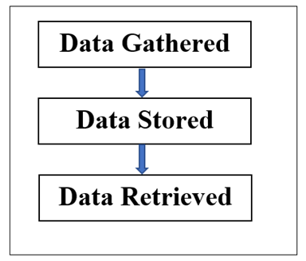

Fig. 1. Data Overview

The aim of this paper provides a process for better results where the organization data can be used for quality out come and the growth of it. The evolution of this paper started because of the big data tremendous role for each organization.

BACKGROUND
The research in big data has been evolved in recent years because of the large data sets that are generating every day where those data sets cannot be handled and managed by traditional tools and software applications are available because these are time consuming and may affect the budget constraint of software project plan. The implementation of big data and data analytics has been started in many organizations for improving the organization business needs giving better results. In the current existing market and society, the impact and the usage of the big data has been booming in various industries and domains for gaining higher possibilities for better decision. Because of large volumes of tremendous data sets existence, it can be analyzed by firstly by use cases, large data gives a greater number of use cases which gives a better understanding of the scenario which gives a better solution for good decision making.

In the existing world people are concerned about the data, they don’t want to focus not only on what they collected but they want to get the importance of it and understand the use of it. The term analysis is varied from analytics where the analysis will be focused on understanding the past history like what happened, how did it happen etc. whereas the term analytics will be focused on the why it happened and it will work further and predict what will be going to be happened in near future. Data analytics will come up with big data in order to analyze the raw data and make decision on the information for organization growth. Furthermore, data analytics is the process of using algorithms and tools on big data to get important data and relationship among the data. At an extent using the algorithms along with some methods like regression, clustering and decision trees etc. making the data more precisely for the people to understand the data.

In the current existing the sample of huge data sets are generated online social media, ecommerce, travel log and many more etc. these industries data sets are generated every second everywhere and millions of these transactional data relationship is not understand by traditional databases queries whereas the data analytics gives the relationship and generates the table records accordingly.

Data overview
Ages ago before the invention of computers the data is used to stored manually by humans. The early invention of data storage was done in punch cards which was a great achievement those days. The punch cards are accessed to communicate the information to the device before the development of computers. The holes on the punched cards used to represent the series of instructions. The later after the great contribution of Charles Babbage the computers came into existence and the usage was of it and production of it was increased rapidly because of the human work is replaceable and done quickly where the time consumed was also less. Later due to usage of computers the storage method was changed from punch cards to magnetic tapes. In two decades, the transformation of data storage has been changed tremendously where the data used to store in floppy disks transformed into compact disks. Now a days the data is stored in disks and flash drives apart from this the very great invention and great contribution to the technology is cloud based services. Here the data is stored in a secured manner and retrieved in safe way without any interruption.

The data stored earlier was in a different way when compared to today. Figure 1 depicts the about the data usage earlier. The consumers or users to collect the data from the others and gathered it and stored for future references and if they need the data, they use to retrieve from it. As data used to collected but did not used for any business purposes for organizational growth, but as the invention and evolution in enhancement of computers and technology the use of data change from one way to other. Figure 2 depicts the extraction of data overview with analysis where data analysis evolved due to enhancement of usage of technology in different domains with competitors in the market the business needs got into considerations where the organizations started focusing on their product by making the analysis of the data what they have for example if any mobile shop has the sales down for the month where he sales only one particular brand. The users in the market

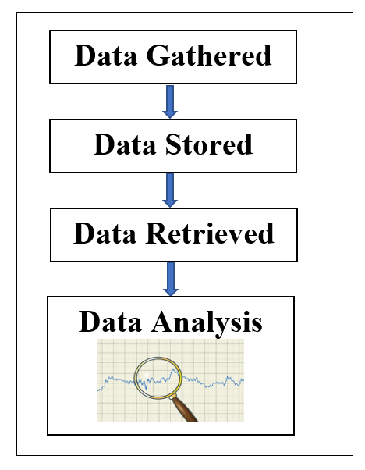
Fig. 2. Data Overview with Analysis

were attracted to the new mobile launch with advance features and started purchasing it. Now the owner needs to find what made his sales down, what new devices came into the market, should focus on the cost of the product and compare with his product. By doing these kind of analysis according to the user purchases the business will developed.

Coming to computers and technology since the data the is stored and retrieved from database by performing queries on the required data and performing analysis. As this method was followed and focused for years even by analyzing the data there was good outcomes in the market. Still this process will be followed by textile merchants in the market. Because of huge and extreme data, it was difficult to handle with the databases to retrieve and analyze the existence of big data and data analytics came into light for helping the organization needs and making better decisions from the data evolved by performing according to those approaches.

BIG DATA
The term big data refers to enormous amount of data, that is which cannot be performed by conventional database systems. Currently big data is one of the most crucial emerging topics in computing. The flow big data deals to analyze the data sets of large data and provide information for decision making for organizations for achieving better results. The goal of the big data is aimed at improving the usage of the resources and storage there by decreasing the computing time and they’re by making excellent business decision for organization growth.

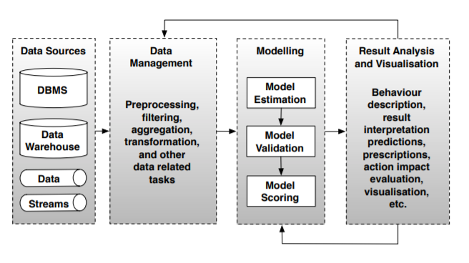
Fig. 3. Data Analytics Workflow

There are three basics characteristics of big data they are volume, velocity and variety. In big data here the term volume means data in huge quantities. Velocity means data streams over the social networking sites like google search engine and tweets on the twitter. Finally, variety refers to data in any and many formats. Here the data can be structured, unstructured and semi structured. In today’s world every day huge data is been created and data is growing at exponential rate and there are not enough people to work on it and analyze it. To overcome these big data presents some aspects to organization like decision criteria, candidate scenario and technology planning implications by using these aspects the organization can achieve some good results for the big data.

Big data provides to achieve some goals to any organization by using it. Like providing Time reduction, cost reduction by implementing Hadoop framework for storing massive data on distributed clusters. and supporting the internal business decisions. The primary idea of the big data is to assist in the interior company decisions like what to be developed and deployed, how much of stock is detained and cost of it and big data is used to deploy new products and offerings in market. The data mining concept in big data environment process does not end for example earlier in last decade there were only few data analysts working on the organization data but today thousands of analysts work for the organization. There are number of organizations using the big data applications. Cloud based analytics as a service is an architecture for the big data in cloud environment.

DATA ANALYTICS
Data analytics is the process of performing on data sets in order to make decision and conclusion on the information they have with help of tools and software applications. In this era where there is rapid growth of internet and communication has developed and there are concern on the data collected and generated. To overcome this the data analytics process workflow, will solve and give solutions in a better and effective way. The Figure 3 depicts the workflow of data analytics. To begin data sources or data gathering is the initial phase, secondly followed by data management and modelling, finally analysis and visualization.

Data resources or data gathering is the initial phase in the analytics workflow where the data sets are collected from different organizations, for example like financial data, banking transactions, stock market data and many more. These will be gathered from different sources like database, warehouses to build models. Once the data is collected and the next phase data management is implemented this is the most crucial and time taking phase because the data need to be sorted, filtered and transformed and filtered and the data sets which give be cleaned where the data fields which are having null values are deleted from the data sets for accurate prediction. By doing data cleaning the data sets will be easy for next phase that is data modelling in this phase the basic models are drawn from the existing data to predict the results how it can be and how it will be and what will happen to the data what we have for future. After modelling the data will be visualized where the results of the data set are view in the form of bar or chart or histogram graphs. In order to perform data analytics there are many software programming languages like python, R and software tools like adobe, tableau and Hadoop are available in the market.

The analytics results are classified into three types they are descriptive and predictive analysis. Descriptive analytics utilizes previous history data to identify the patterns and create the reports based on the past behavior whereas on the other hand predictive analytics predicts the future by analyzing the current data and the history data. Finally, in order to perform on the data analytics and achieve solutions for the organization significant effort is needed.
The analytics results are classified into three types they are descriptive and predictive analysis. Descriptive analytics utilizes previous history data to identify the patterns and create the reports based on the past behavior whereas on the other hand predictive analytics predicts the future by analyzing the current data and the history data. Finally, in order to perform on the data analytics and achieve solutions for the organization significant effort is needed.

Big data and data analytics impact in organization
The Figure 4 depicts the transformation of the data from big data to data analytics and providing the better decisions. In the figure it is clear where are three different colors which represent the data set where the color sky blue is one data field of the data set, pink is another data field of the data set and dark blue is another data field of the data set. Where all the three colors represent different data fields of the data set initially when data big data is performed on the data set it gives some form to the data and secondly when data analytics is performed it will categorized the data into the accurate data fields without redundancy in the data and thus transforming the dataset data into decision making.

Decision making based on analytics is a primary concern for the organizations to improve their work progress in terms of customer acquisition and customer service. Big data provides a tool for data analytics to enhance the results with statistical samples. In general, the for any large data sets sample will have the accurate results. Most of the latest tools and applications, techniques are available for big data and data analytics but there’s a lot to learn from the data because to leverage the data for the organizations so that they can be benefited from them.

In today’s world there are some barriers for data analytics the first and the most prominent one is staffing and skills for the using it. There are some more consequences with the database and software support failure during the analysis of the data.

There is lack of subject matter experts for decision taking and involvement and other factors all also affect. In this current available market big data is not a consequence it’s an opportunity to work and learn and challenge role and which give rise to many new opportunities. In most cases the owner of the big data analytics is owned by the team who work on business intelligence and the data warehouse.

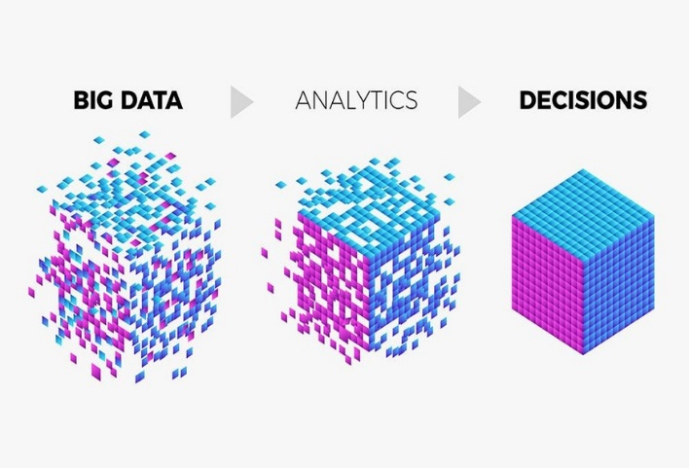

Fig. 4. Data Set View

In pervious section its was described where three different data structures. The structured data is maintaining the data in the form of tables. Whereas the semi structured data will be handling data of extended markup language. The web data is hype these days because of most of the population now depended on the internet and even all the works are done through internet like shopping, booking tickets for travelling movie concerts and many other purposes so each time the user use the internet the analytics tool be running on the back end application where these tools helps the organization for the user interests and will be helpful for the users for next time when try to search for the similar things it will suggests them quickly with the nearby location and the best things.

There are some pros and cons with the available data analytics tools and techniques in the market because there many options there and knowing which the best one and getting training on them is a time-consuming factor. Exploring data and discovering the new changes that required for the business using the data will give a way for new product development and the which reduce the cost. The newer concepts involved the more can be learned from big data and think it an opportunity. Keep in view the three aspects of the big data that can help while streaming the real time data.

The business data analytics is based on the performance of the business data. Where the operations of the business generate huge amount of data from consumer information, ecommerce information and many more. Since the data become massive there have need to be way to gain powerful insights and make efficient decisions on the business improvement. The correct the use of analytics in

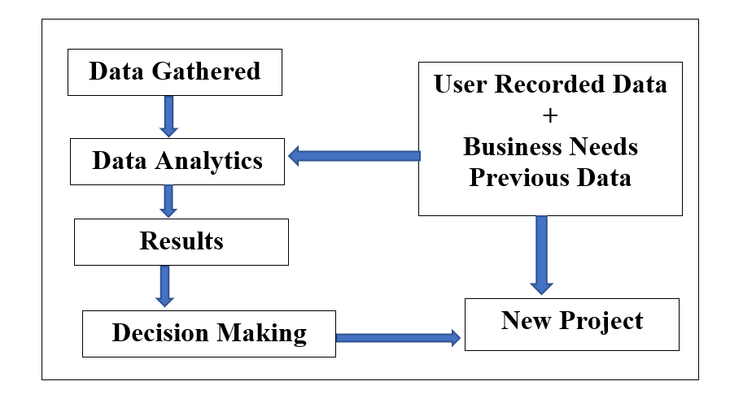

Fig. 5. Proposed system architecture view

business makes a competitive advantage for the organizations. In order to get an effective analytics in business requires involvement of different experts who need to have set some objectives and decisions and someone who need to have strong database skills to manage accordingly and someone who need to be data analysis expert to understand data mining and statistics for data analyzing. When these three experts meet then there will be an optimal solution. The data analytics and big data also deals with privacy issues like data fraud detection. These will help the cyber team in fact for security

proposed system.
The figure 5 depicts the proposed system. The aim of this system is to provide the better solution for the organization in order to develop new products along with the data they have and collected. Initially the data is gathered and along with the user record and business need previous data on these data analytics is performed to get the accurate results from the data set and finally these results are used in decision making and future based on these implementation of new products can be done effectively in such a way organization can give the competition to other competitors and thus benefiting the organization growth. Here the user record consists of the user transaction history for example when a user purchases a shirt via online using ecommerce where the user history needed to be stored by the application in order to track the customer information based on their previous transaction’s so that the merchant

can know what patterns the customer likes and color and what trends he is following. If these kind of data is stored under the user record, then there will be great benefit by organization future with the help of data analytics the results can be predicted accurately and there by the organization can develop new products based on this proposed system easily to achieve quick growth in the market and makes the organization revenue high.

In general, if this proposed is followed by any organization it will make their work easy because they have user recorded data and previous business data. Here in the data analytics phase all the phases as described earlier will occur starting form data sources followed by data cleaning, modeling, and finally visualizing. This is a cyclic process where every time it begins there will be a generated data from the previous analysis thus making the analysis and results appear quicker and making the decisions by organization authorities.

One of the important concept of this proposed model is data generation and user data is collected and layered rather than throwing the unwanted or unconnected data into analytics and organizing it makes a way and helps to generate more data accurately. With the assistance of efficient algorithms, the present research carried out by data analytics instruments and applicationcan be automated to produce faster and more precise outcomes and there are number of applications that provide faster results.

applications
In general, there are many applications using data analytics in various fields like health care, transportation, financial data for banking, climatic data for weather and geographical data. Apart from these there are many other where data is generated every second and data analytics play a prominent role in evaluating them by tools and thus data sets are used to predict the results. However, in some scenarios the data can be reused for prediction so store them makes come use in future.

In health care patients’ records, hospital management is recorded every day and every second where there are number of incoming and outgoing patients will generated large data sets.

In travel industry every day every hour the data will be updated because of the number of people travelling from one location to another location the data can be generated, and data sets used are helpful for the companies to offer promos to their customers.

The banking people will use the data analytics tool for predicting the user credit usage and transactions and will decide whether to give a loan or not.

In sports data analytics is used to predict the opponent behavior and score and review of the match how is it is going on.

Conclusion
Data analytics is leveraging the data in order to help the organization growth. Data analytics and big data are booming because of the precise analysis done on the massive amount of data.

The proposed model in this paper makes a great contribution to organization growth because of the user recorded data makes a great contribution to organization growth because of the user recorded data.

In the current market there is good way to learn data analytics and the big data with variety of data sets available. If you want to try doing the prediction and analysis on the data and data set there is Kaggle site which is online for free where the users can login and work on the data for different projects and it’s a competition connected via cloud computing where any number of users can participate in data set and predict the values for the data and provide the best result. The person wins the competition will be awarded with the cash memento.

Future work
The current work carried out by data analytic tools and applications can be made automated with the help of effective algorithms in order to make quicker and accurate results.

References

- K. 1. Adams, M.N.: Perspectives on Data Mining. International Journal of Market Research 52(1), 11–19 (2010)
- Bakshi, K.: Considerations for Big Data: Architecture and Approaches. In: Proceedings ofthe IEEE Aerospace Conference, pp. 1–7 (2012)
- Chen, H, Roger HL Chiang, and Veda C. Storey. "Business Intelligence and Analytics: From Big Data to Big Impact." MIS quarterly 36.4 (2012): 1165-1188.
- venport, H., and Jill ,D. "Big data in big companies." International Institute for Analytics (20

.

